# 

# 

# 

# PATAN COLLEGE FOR PROFESSIONAL STUDIES

# Individual Reflective Report

# 

# 

# 

# Ujaalo Student Information Kiosk

# PROJECT REPORT

# Submitted by Submitted to

# Lokendra Dangi (1720849) UOB

# 

**Individual Reflective Report**

This form is submitted by every member of your group and used to assess the level of teamwork in your group and the contribution of individuals. It may also form the basis of discussions which affect the grades received by individual group members.

|  |  |  |  |
| --- | --- | --- | --- |
| Student Number | First Name | Last Name | Group No |
| 1720849 | Lokendra | Dangi | 1 |

University of Bedfordshire given the assignment of student information system that helps student to keep updated up to date event and information given by the premises. Student information system Kiosk help new student to register to the system and perform various operation in the campus area. In this project I have chance to involved in many fields starting from the primary research to the end of development of the software. I am also involved in the design and prototyping of the software. I involved with every group member of the project so that each point view can be consider while designing prototype

**Work Division**

|  |  |  |  |
| --- | --- | --- | --- |
| **S. N.** | **Name** | **GUI &**  **Implementation** | **Diagrams &**  **Documentation** |
| 1 | Kshitij Bajagain | Student Dashboard , Events & Booking, My/All Booking , Account Details ,Clubs , Admin Dashboard design and their functionalities | ER Diagram, Class Diagram, Design and implementation, work division. |
| 2 | Lokendra Dangi | Add Events , Alter Events , Update Events, Delete Events design and their functionalities | UseCase Diagram, Class Diagram, Introduction of report, Testing part. |
| 3 | Buddha Lama | Register Page , Login Page , Why Us , Help, Brochure, Accommodation , User Information(admin) design and their functionalities | Sequence Diagram, Class Diagram. Project plan. |
| 4 | Prabin Chapagain | Browser Functionality , Campuses (Luton, Bedford, Aylesbury, Milton Keynes, Putter ridge , Patan College) ,Education Loan | Activity Diagram, Class Diagram, agile and primary research. |
| 5 | Prajwol Thapa | Splash Screen , Kiosk Main Home Courses(Undergraduate , graduate , Foundation and International Students) , Invoice Generation | Sequence Diagram, Class Diagram, aims and objectives and critical analysis. |

Every team member has contributed according work division mentioned above. I worked and contributed my portion during the whole software development phase according above work division only. My work with screenshots along with code snippets are mentioned in my contribution part of this individual reflective report.

Evaluating team member’s work I have attested a table below which rates their work during project development.

|  |  |  |  |
| --- | --- | --- | --- |
| Student Number | First Name | Last Name | Contribution  (N,S,I) |
| 1723936 | Buddha | Lama | S |
| 1723333 | Kshitij | Bajagain | S |
| 1721484 | Prabin | Chapagain | S |
| 1721479 | Prajwol | Thapa | S |

**S** -Significant (The group member’s work was integral to the overall submission)

**N** -No Contribution (The group member took no part in the project submission)

**I** -Insignificant (The group member’s work made little difference to the overall submission)

At last, I am so proud that my group successfully did the project .It was great opportunity working with awesome team-members I had incredible time working with my team member.

**My Contribution Snippets:**

**These are following snippets of my work division which I did during software development.**

1. **UML Diagrams(Use-Case Diagram)**

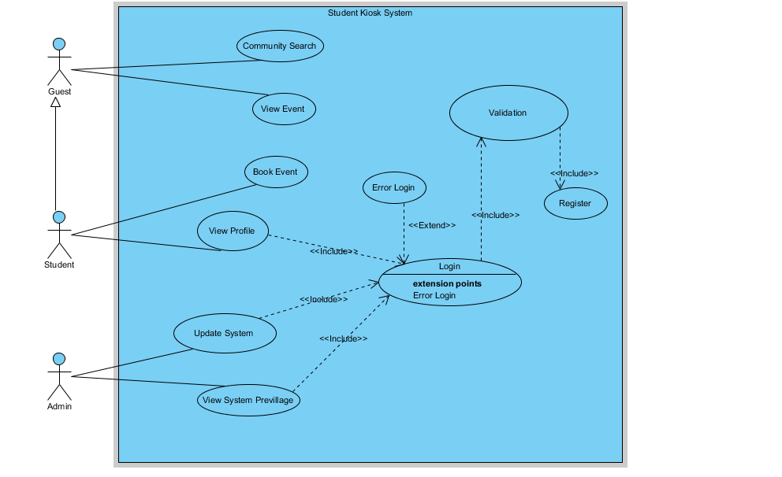

1. **GUI Templates which I did:**

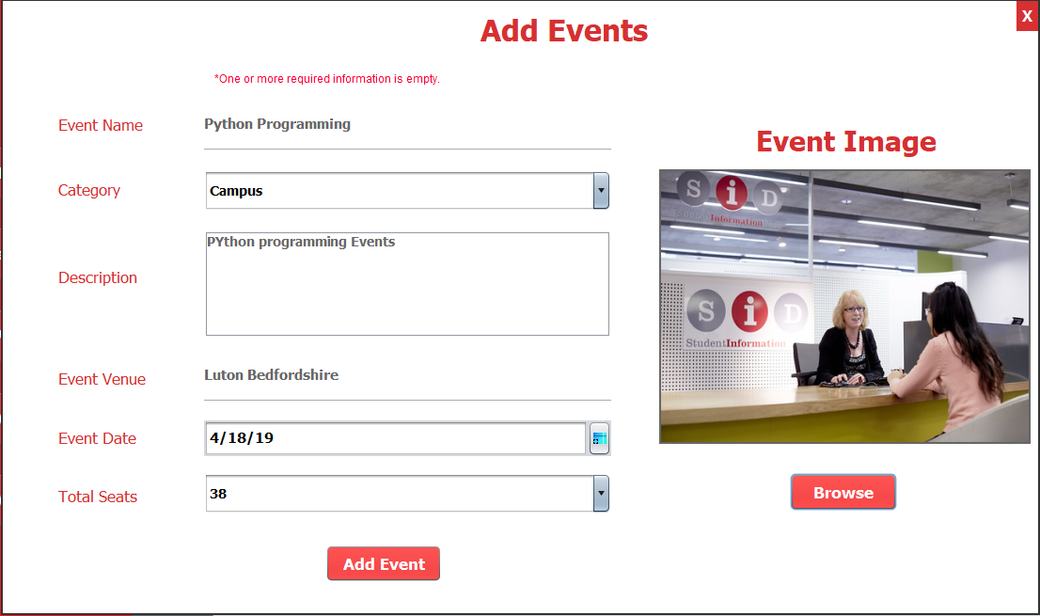These are the functions that I have did during software development

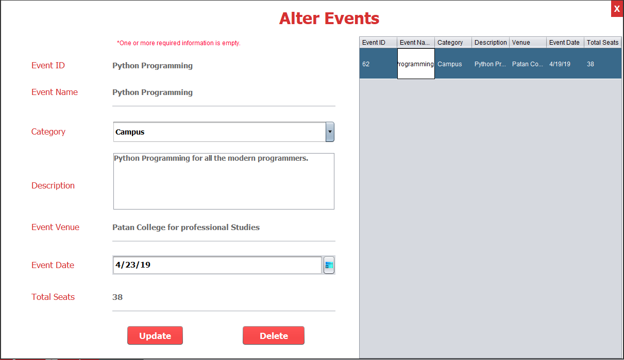

1. **Codes Snippets:**

**These are screenshots of codes that I did it but whole version of code is submitted in along with group report.